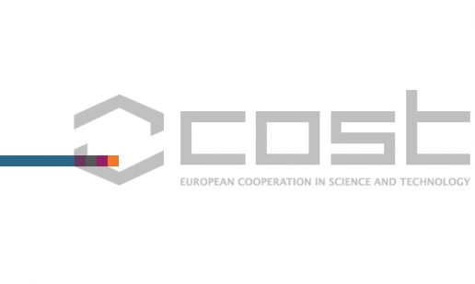
Aarhus and Copenhagen University jointly host the annual cost PhenomenALL meeting in Copenhagen 18-20 April 2016.

Phenotyping is an emerging science that characterises plant behaviour and quantifies features such as growth and stress tolerance in a way that allows linking to genetic control. This network of European scientists with expertise on phenotyping, various -omics areas and/or physiology to (re)discover tolerant varieties and to understand crop tolerance. PhenomenALL will survey knowledge about plant biodiversity with respect to stress tolerance and will share and group existing expertise into discussions and conceptual development of new tools in phenotyping by integrating information from the cellular level to the whole plant level.
While significant progress has been made in molecular and genetic analysis of model plants, the quantitative high throughput screening for crops is a major bottleneck. Reliable identification of tolerant varieties and the understanding of their genetic diversity are urgently needed.
Attendance of this COST meeting is free of registration fees and includes admission to all sessions, symposium and in part lunches, dinners, coffees and refreshments, guided tours and abstract book.

For further information consult the homepage http://www.plant-phenotyping.org/home_of_2nd_meeting.

For more info: Info.PhenomenAll2016@food.au.dk

Carl-Otto Ottosen, Dept of Food, member of COST coregroup and coconvener

